SYLLABUS:
POSITIVE INTEGERS

ARTIFICIAL CHANAKYA
2019-2020

DATE: 17/03/2019
EXPERIMENT NO: 110011
ARTIFICIAL CHANAKYA

AIM:
Trying to understand the relationship between the different parameters of F&B industry and the contribution of commission payouts to overall sales and market share of each product, brand and company.

APPARATUS REQUIRED:

- 50ml of numpy, pandas, matplotlib and seaborn for preparing the visualization solution
- 25ml of scikit-learn solution
- 25ml of xcode ios developing solution
And mixing the right proportions using the python base solution to get the required results analysis and jupyter notebooks buffer solution.

PROCEDURE:

- Converting the month to a numerical value for a perfect ordering.
- Splitting the data set into separate companies’ test tubes for a better analysis.
- Graphical representation to represent the relationship between different parameters.
Indicatory test1: Org. Sol. vs month for different companies.
Indicatory test2: Org. Sol. vs area1 for different companies.
Indicatory test3: Org. Sol. vs area2 for different companies.
- Separation of the solution based on product category1.
Indicatory test4: six different observations based on Org. Sol. vs commission
- To perform the confirmatory test for the market share effect:
Confirmatory test 1: pie chart of Org. Sol. vs product category for different company solutions.
Confirmatory test 2: pie chart of Org. Sol. vs area1 for different company solutions.
Confirmatory test 3: pie chart of commission vs product category for different company solutions.
Confirmatory test 4: pie chart of Org. Sol. vs outlet types for different company solutions.

- The finale is to perform the verification tests:
Test 1: area2 vs Org. Sol. for different company solutions.
Test 2: area3 outlet type vs Org. Sol. for different company solutions.
- Ratio test:
Creating a ratio solution of revenue and commission.
Ratio test 1: area1 vs ratio solution of companies.
Ratio test 2: area2 vs ratio solution of companies.
Ratio test 3: product category1 vs ratio solution of companies.

OBSERVATION:

- INDICATORY TABLE:
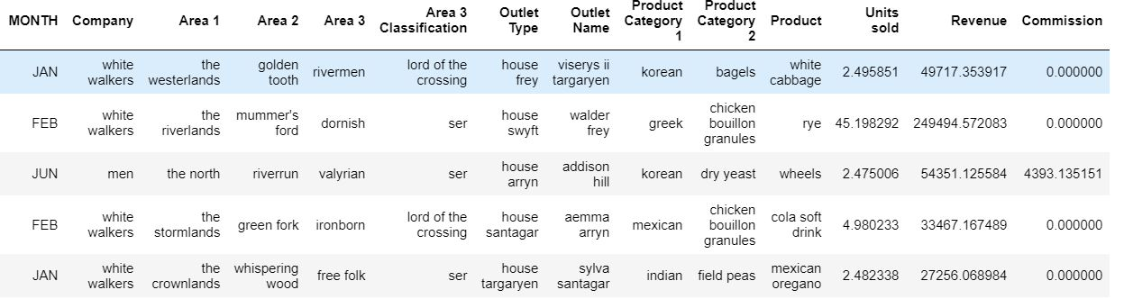

- CONFIRMATORY TABLE:
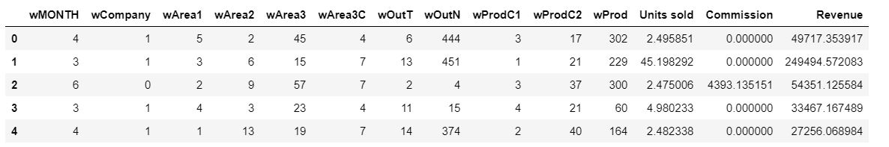

ROUGH GRAPH:

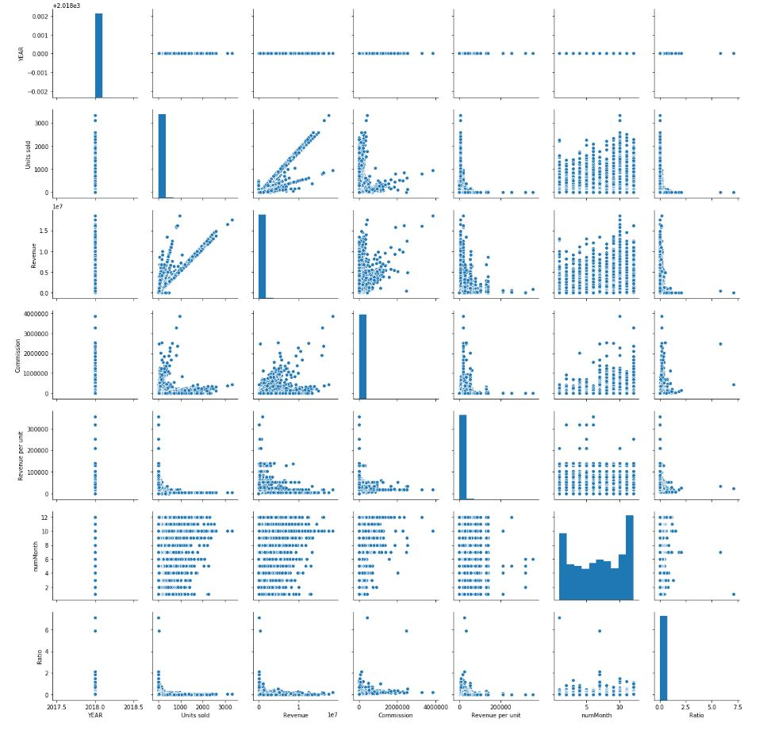

GRAPH:
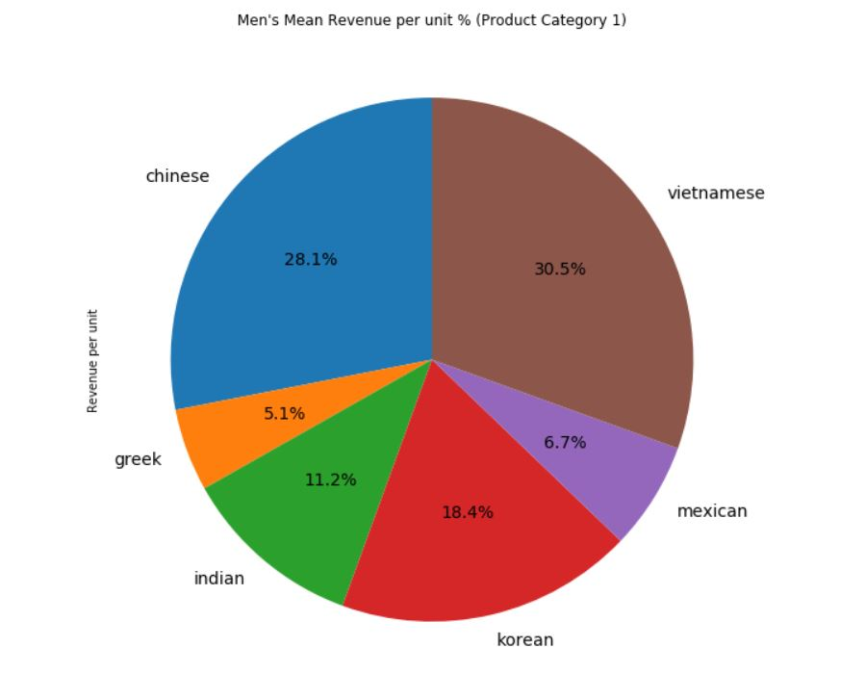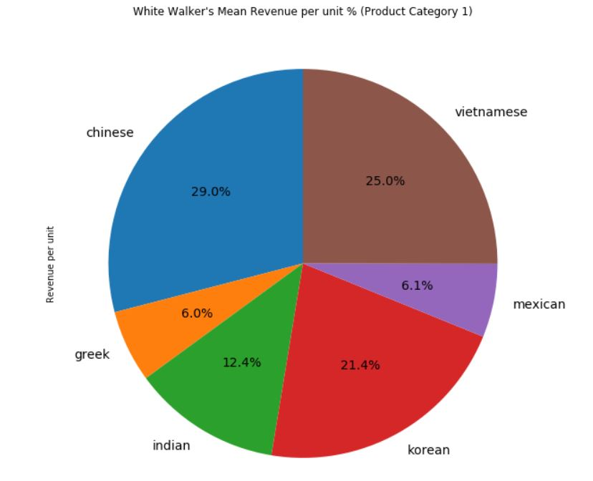

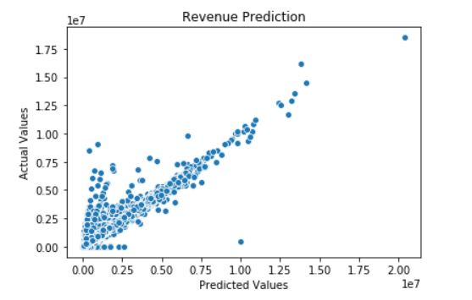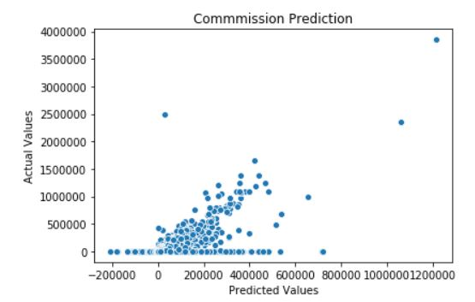

EMPIRICAL FORMULA:

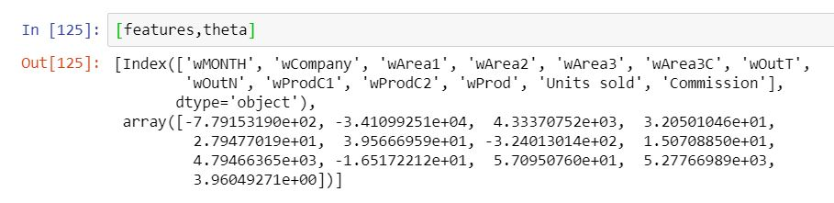

RESULT:

On the basis of the above analysis we will conclude the required sales model out of the following:

- SPIN
- NEAT
- CONCEPTUAL SELLING
- CUSTOMER CENTRIC
- CHALLENGES SALES

Hence the experiment has been successfully visualized, analyzed and predicted.

